F.13 -

Functionality
Automatic clearing allows you to clear many GL accounts in one transaction run. You can use a test mode to check your entries before posting takes place.
In customizing you can define up to three fields that are treated by the system as the sort criteria for clearing. For instance, you can decide that all the documents with the same value in the field “Assignment” can be cleared.

Scenario
Certain GL accounts, e.g. accrual, that are managed on open item basis, have debits & credits transactions. At the end of each month, you want to match (clear) certain debits to credits automatically.

Requirements
The GL accounts must be flagged as open item.

Menu Path | Accounting → Financial Accounting → General Ledger → Periodic Processing → Automatic Clearing → F.13 - Without Specification of Clearing Currency
Transaction Code | F.13

1. Double click on F.13 - Without Specification of Clearing Currency

Automatic Clearing without Definition of Clearing Currency (SAPF124)

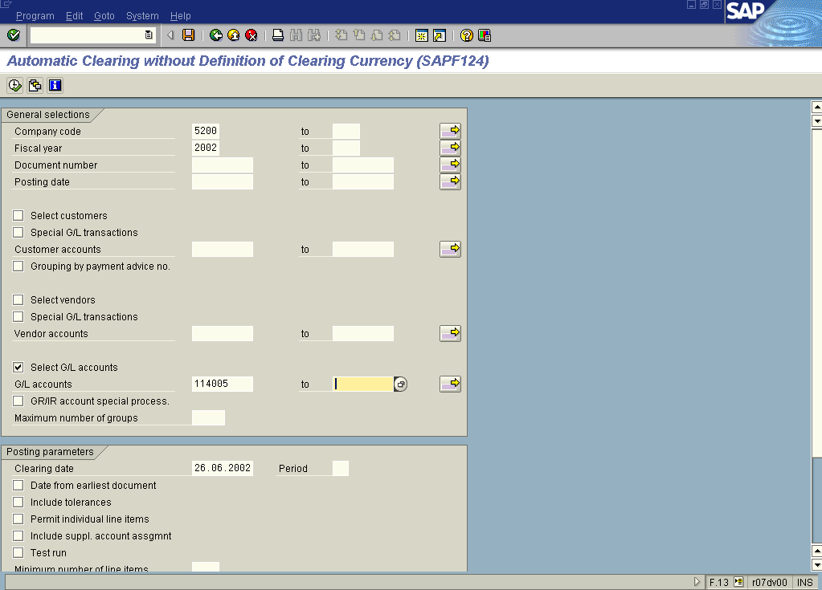

2. Update the following fields:

Field Name | Field Description | Values
Company code | Code identifying a separate legal entity for which a separate set of accounts is maintained for external reporting purposes | Example: 5200
Fiscal year | Fiscal year number | Example: 2002

3. Now click Select GL Accounts Button . You want to process only general ledger accounts, so DO NOT SELECT other types of accounts.

4. Now enter the account number. You can enter a range of accounts (usual setting). In this example to simplify presentation only one general ledger account is selected:

Field Name | Field Description | Values
General ledger accounts | Number of general ledger account | Example: 114005

5. At the bottom of the screen (you need to use a mouse to scroll the screen down) there’s another radio button you need to select. Click Only docs which can be cleared . This way the system will clear only the documents that fulfill pre-defined clearing criteria (e.g. like the same assignment number).
6. By default the system is in the test mode. Click Test run button to turn it off.

7. You entered the selection criteria. Now click Execute Button to begin clearing procedure.

Automatic Clearing without Definition of Clearing Currency (SAPF124)

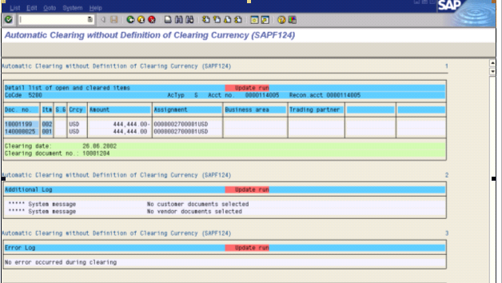

8. The message bar displays “Document number xxxxxxx posted in company code 5200”.

 This is the clearing document number. No real posting took place.

